Chapter 9, Solution 88.

- 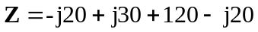
Z = (120 – j10) 

- If the frequency were halved, 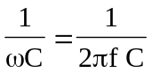 would cause the capacitive impedance to double, while 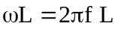 would cause the inductive impedance to halve. Thus,
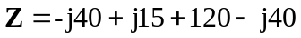
Z = (120 – j65) 

